Class timing- Tuesday , Thursday

Assignment submission form:https://forms.gle/EbKTzLd7DyBccip49
Deadline: before next class(Tuesday)

13/12/2022

- WAP to accept two numbers from the user and display their sum

- WAP to accept radius of a Circle from the user and calculate area and circumference

- WAP to accept roll number , grade and percentage as input from the user and display it back

- Write a program that asks the user to enter his/her name and age. Print out a message , displaying the user’s name along with the year in which they will turn 100 years old.
- Write a program that asks the user to input 2 integers and adds them . Accept both the numbers in a single line only

- Write a Python program which accepts the user's first and last name and print them in reverse order with a space between them.
—-----------------------------------------------------------------

15/12/2022

- WAP to accept an integer from the user and check whether it is an even or odd
- WAP to accept a character from the user and check whether it is a capital letter or small letter. Assume user will input only alphabets

- WAP to accept a character from the user and check whether it is a capital letter or small letter or a digit or some special symbol

- WAP to accept 3 integers from the user and without using any logical operator and cascading of relational operators , find out the greatest number amongst them

—--------------------------------------------------------------
- WAP to accept a year from the user and check whether it is a leap year or not.
An year is a leap year if:
It is exactly divisible by 4 and at the same time not
divisible by 100
OR
It is divisible by 400
For example:
2017 is not a leap year
2012 is a leap year
1900 is a not leap year
2000 is a leap year

- You have to develop a number guessing game. Following are the steps needed:
- At first , the program will generate a random integer secretly.

- Now it will ask the user to guess that number .

- If the user guessed it correctly then the program prints “Congratulations! You guessed it right” .

- But if the number guessed by the user is larger than the secret number then program should print “Number too large” and , if the number guessed by the user is smaller than the secret number then the program should print “Number too small”

- This should continue until the user guesses the number correctly or quits .

- If the user wants to quit in between he will have to type 0 or negative number

—-----------------------------------------------------------------

- Write a program to accept a string from the user and display it vertically but don’t display the vowels in it.

- Write a program to continuously accept integers from the user until the user types 0 and as soon as 0 is entered display sum of all the nos entered before 0
Note:Modify the previous code so that if the user inputs a negative integer , your program should ignore it .

- Write a program using a for loop to accept a string from the user and display it vertically but don’t display the vowels in it.

- Write a program to accept an integer from the user and display the sum of all the numbers from 1 to that number.

- Write a program to accept an integer from the user and calculate its factorial
- Write a program to print the following pattern
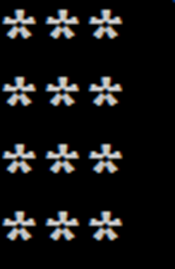

- Write a program to print the following pattern
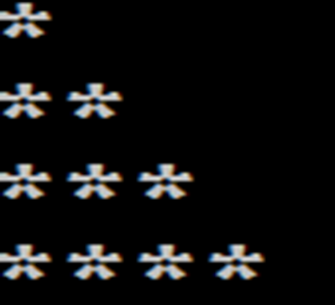

- Write a program to print the following pattern
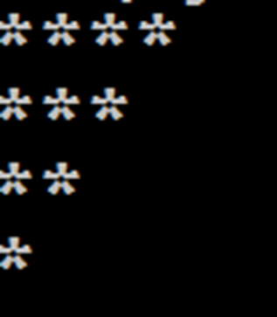

- Write a program to accept an integer from the user and display all the numbers from 1 to that number. Repeat the process until the user enters 0.

